Figure S1. Length disribution of the miRNA in high-FE and low-FE pig liver libraries. This figure show the percentage distribution of the read lengths against the total counts in the miRNA reads of High-FE and Low-FE pig liver libraries .
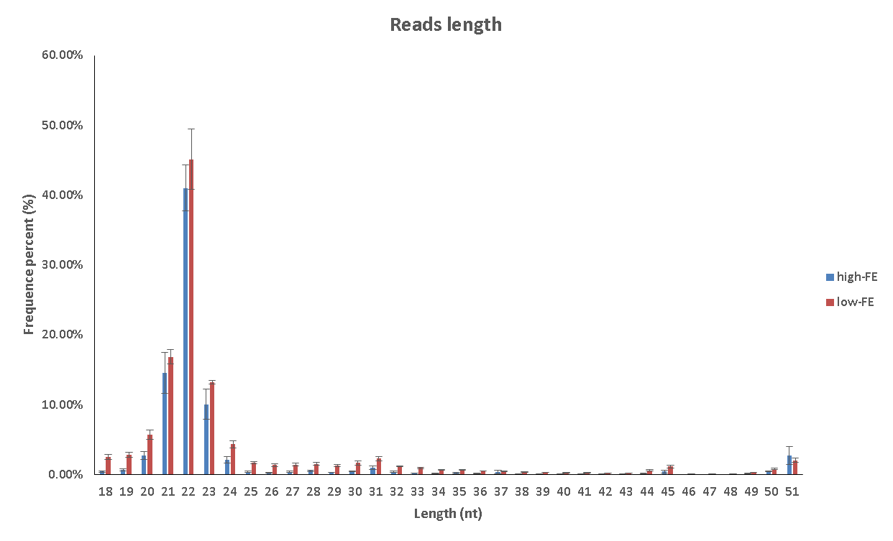

Figure S2. Venn diagram of the mature miRBase miRNA in high-FE and low-FE pig liver libraries.

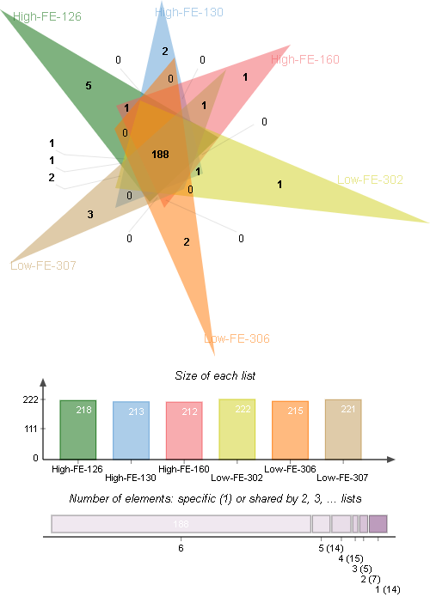

Figure S3. Venn diagram of the novel miRNA predicted by miRDeep2 in high-FE and low-FE pig liver libraries.
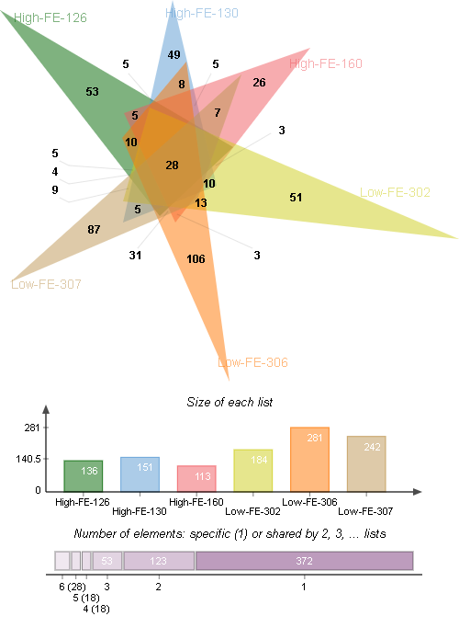

Figure S4. Predicted secondary structures of novel miRNAs. The red color indicates the mature sequence, the yellow color indicates the loop sequence, the blue color indicates the predicted star sequence, and the purple indicates the miRNA star sequences.
